Presentation from The Secretary of State for Housing, Communities & Local Government

Rt Hon Robert Jenrick MP

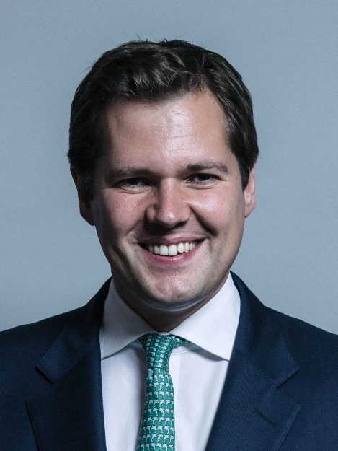

- Robert Jenrick was appointed Secretary of State for Housing, Communities and Local Government on 24 July 2019.

- Robert was Exchequer Secretary to the Treasury from 9 January 2018 to 24 July 2019. He was elected Conservative MP for Newark in June 2014.

- Robert is also Ministerial Champion for the Midlands Engine.

- The minister is responsible for the overall leadership and strategic direction of the department. Responsibilities include:

4.1 Strategic oversight of the department’s business
4.2 Midlands Engine Champion
4.3 Chair Grenfell Ministerial Recovery Group

- Robert entered Parliament following a by-election in June 2014. He served on the Health Select Committee from July 2014 until he was appointed Parliamentary Private Secretary to the Minister for Employment at the Department for Work and Pensions. He was appointed as Parliamentary Private Secretary to the Lord Chancellor and Secretary of State for Justice in May 2015 and from June 2017 served as Parliamentary Private Secretary to the Home Secretary. From July 2017 until his appointment as Exchequer Secretary he was a member of the Board of the Conservative Party.

